Coronaviruses – What They Are and How They Can Make You Sick

1. What do you know about COVID-19 and the novel coronavirus that causes COVID-19? What questions do you have?

Introduction to Coronaviruses

There are many different types of coronavirus that infect many different types of animals. In 2019 a novel coronavirus began to cause illness and deaths in humans. By March 1, 2022, this novel coronavirus had caused over 6 million deaths worldwide and over 0.9 million deaths in the US.

To learn about this novel coronavirus:

• view “SARS-CoV-2 Infection” (https://media.hhmi.org/biointeractive/click/covid/infection.html)

• read “How coronaviruses replicate inside you” (https://www.latimes.com/projects/how-coronavirus-invade-cells-replicates/).

2a. Fill in the blanks in this flowchart to describe how new coronaviruses are made.
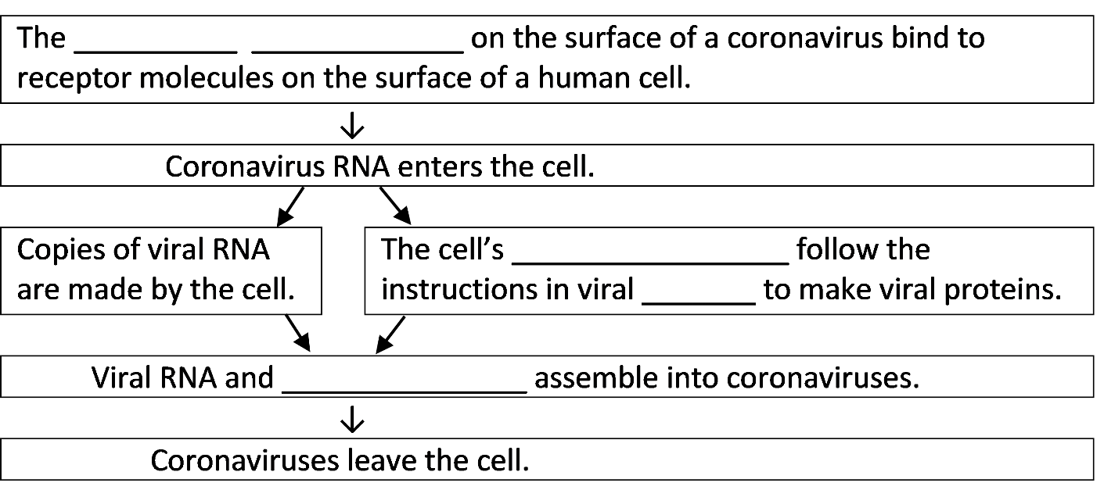
2b. Explain why a coronavirus can’t reproduce on its own and instead needs to use our cells to make more coronaviruses.

2c. How big is a coronavirus compared to your cells?

How can something so tiny make a person sick?

Cells infected with the coronavirus usually die after producing hundreds of coronaviruses. These coronaviruses infect other cells, which also die. To understand how a coronavirus infection can cause serious illness, you will need to understand the basics of the respiratory system and circulatory system.

The cells in your body need a constant supply of oxygen to survive. This figure shows how your respiratory system brings oxygen to your blood. Your blood carries oxygen to all the cells in your body.
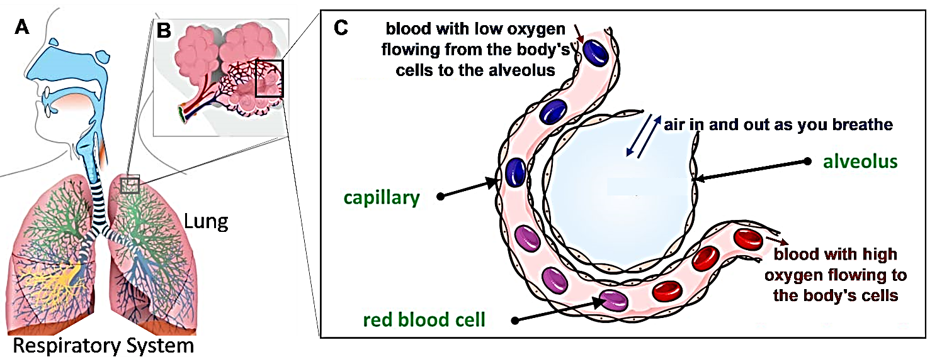
A. When you breathe in, you bring air with oxygen into your lungs. | B. Inside your lungs there are millions of tiny air sacs, called alveoli. | C. Each alveolus is surrounded by a network of capillaries (tiny blood vessels). Oxygen diffuses from the air in the alveoli to the blood in the capillaries. The blood carries oxygen to all the cells in your body.

3a. In the diagram of the respiratory system (figure A), draw a long arrow to show how air with oxygen reaches the lungs.

3b. In the diagram of the alveolus (figure C), draw an arrow to show how oxygen diffuses from
the air in the alveolus into the blood.

4. Explain how the respiratory system and circulatory system cooperate to provide the body’s cells with a constant supply of oxygen.

For a review, and to learn how a coronavirus infection can reduce oxygen in the blood, view the first 5 minutes of “What happens if you get COVID-19?” (https://www.youtube.com/watch?v=5DGwOJXSxqg).

Your immune system tries to get rid of a coronavirus infection. For example, some of your white blood cells attack and destroy both the coronaviruses and any infected cells.

5. Why is it useful for white blood cells to attack cells that have been infected with coronavirus?

In response to an infection, white blood cells also release chemical signals that stimulate inflammation. Inflammation opens gaps between the cells in the walls of the capillaries; these gaps
allow white blood cells to move from the blood to the surrounding tissue.  6. Explain how inflammation can help to fight a coronavirus infection. | 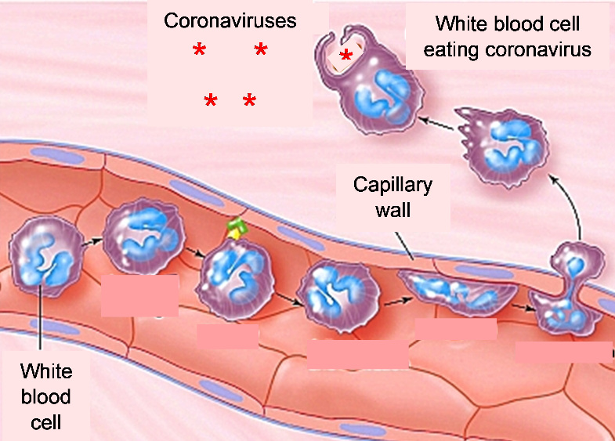

Inflammation can also have harmful effects. This figure shows that inflammation can result in the accumulation of fluid in and around the alveoli. This fluid slows the diffusion of oxygen into the blood, which results in low levels of oxygen in the blood.  7. Draw an arrow that shows how oxygen from the air in the alveolus must diffuse through fluid to reach the blood. | 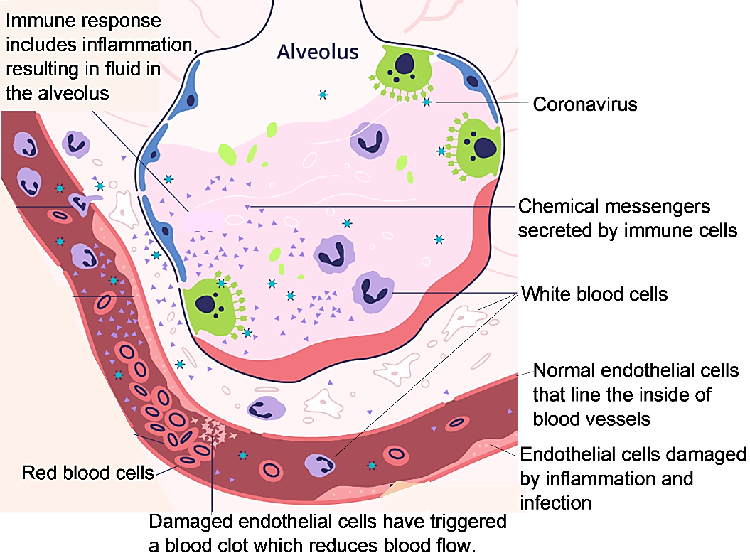
The cells in the capillary walls can be damaged by coronavirus infection and inflammation. The damaged cells in the capillary walls trigger blood clots. Blood clots reduce blood flow.

In a severe coronavirus infection, the combination of reduced blood flow and low blood oxygen results in decreased oxygen supply for the body’s cells. Decreased oxygen supply can damage the heart and other organs; this contributes to severe illness and even death.
8. Describe two ways that the body’s responses to a coronavirus infection can reduce the amount of oxygen that reaches the body’s cells.

In response to a coronavirus infection, white blood cells release chemical signals that cause inflammation, fever and fatigue. Fever and fatigue contribute to feeling sick when a person has a coronavirus infection, but they also help to fight the infection. The increase in body temperature improves immune system function. Because the person feels tired, he or she rests more, so more energy is available for fighting the coronavirus infection.

9. Although some people infected with coronavirus suffer severe illness, many people recover without the need for medical treatment. Draw a flowchart to show how the responses of white blood cells can get rid of a coronavirus infection, even without any medical treatment. A complete answer will include inflammation, chemical signals, fever and fatigue.

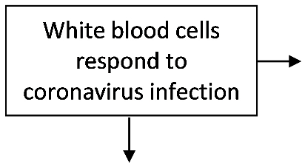

10. Add to the above flowchart to show how a coronavirus infection can result in severe illness. Include the ways that the body’s responses to a coronavirus infection can affect the supply of oxygen to the heart and other crucial organs.

By Dr. Ingrid Waldron, Dept Biology, Univ Pennsylvania, © 2022; this Student Handout, a shorter version, and Teacher Notes (with instructional suggestions and background biology) are available at https://serendipstudio.org/exchange/bioactivities/coronavirusintro.

